附件一
海口排水滯洪池座標:X167196.505，Y2622339.605
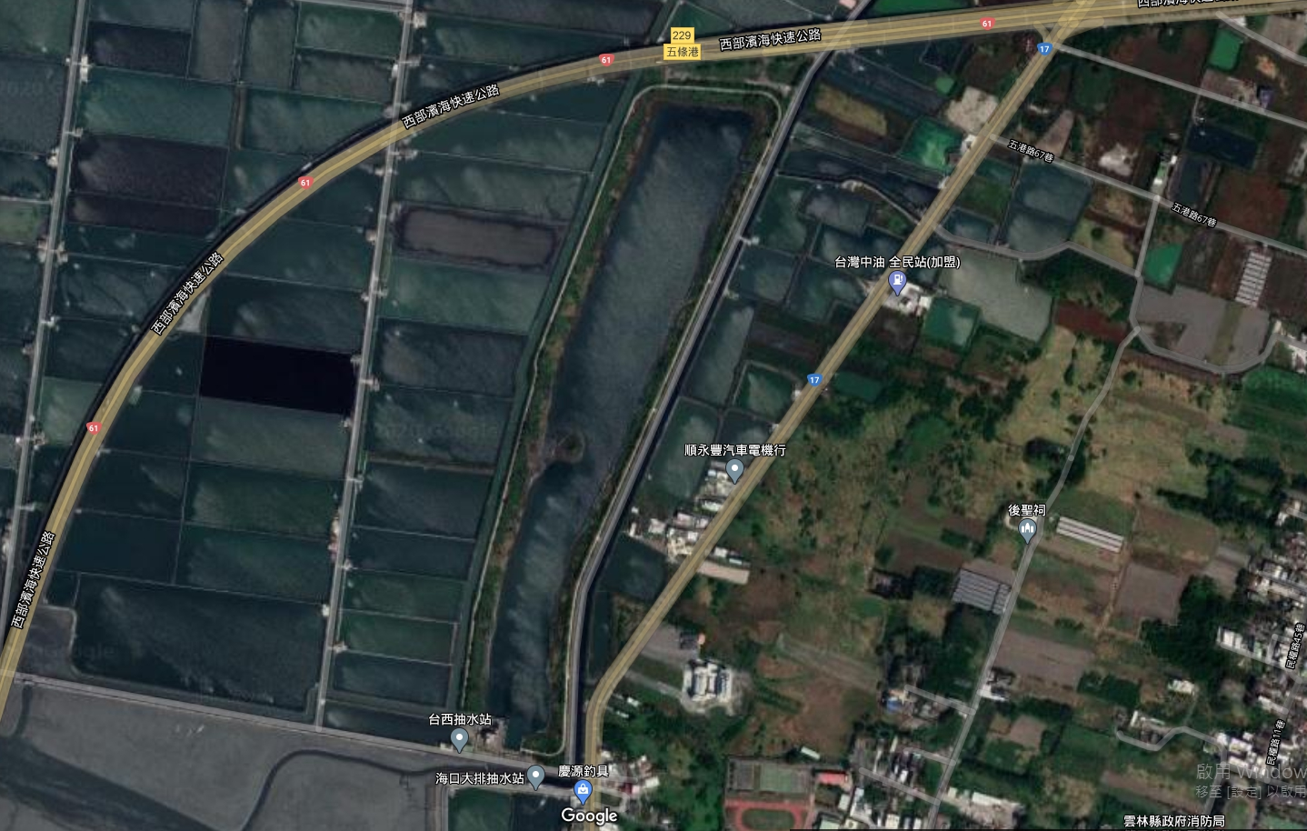
海口排水滯洪池

